# 

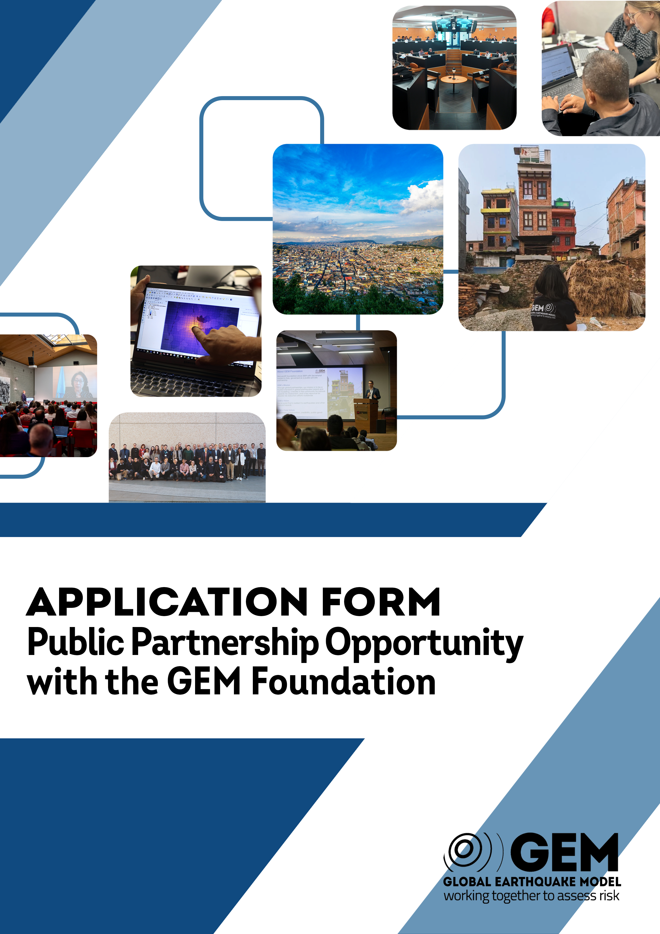

# Public Partnership Opportunity with the GEM Foundation

# Date: 12th March 2025

*Please prepare your proposals with this Application Template and convert to a PDF file. Please ensure that your responses are clear and concise. If your organisation can provide additional supporting documents (e.g., reports, case studies, project summaries), you may attach them to your application.*

*The Application PDF (and any supporting documents) must be sent to the email address* [*secretarial@globalquakemodel.org*](mailto:secretarial@globalquakemodel.org) *with the subject line: "Application for Public Sector Partnership Opportunity with GEM Foundation”*

*Interested applicants are requested to submit their application* ***by 23:59 hrs (CEST) on 24th May 2025****. Responses received after the stipulated time, or not in accordance with the template instructions, will be rejected.*

***Note:*** *Please read carefully the conditions set out in the Call for Applications document. Pay particular attention to the selection criteria; they explain how the application will be evaluated.*

|  |  |
| --- | --- |
| **ORGANISATION INFORMATION** | |
| **Organisation Name:** | Insert text |
| **Country:** | Insert text |
| **Contact person:** | Insert text |
| **Position/role:** | Insert text |
| **Contact Email:** | Insert text |
| **Website (if available):** | Insert text |

# 1. Opportunities for collaboration

|  |  |
| --- | --- |
| **Ongoing and Future Earthquake-Related Initiatives**  *Describe any ongoing or potential future earthquake-related initiatives, programmes, or projects in your country that aim to assess hazard, reduce earthquake risk, increase preparedness, or enhance public safety. What is their contribution to public good and are they publicly accessible? How do they align with GEM’s mission, core values and vision?*  *Repeat this table for each initiative, as necessary* | |
| **Initiative/Project Name(s):** | Insert text |
| **Description:** | Insert text |
| **Objectives and key results:** | Insert text |
| **Target Beneficiaries (e.g., local communities, government agencies, public sector):** | Insert text |
| **Impact on Public Safety/Preparedness:** | Insert text |
| **Alignment with GEM’s mission, core values and vision:** | Insert text |
| **Links to openly available resources:** | Insert text |

|  |
| --- |
| **Ongoing and Future Earthquake-Related Initiatives**  *How do you envisage a closer collaboration with the GEM Foundation and how would that partnership support these initiatives and activities?* |
| Insert text |

# 2. National hazard/risk assessment responsibilities

|  |
| --- |
| **Role in National Hazard/Risk Assessment**  *Explain your organisation’s responsibility in the national earthquake hazard/risk assessment efforts. What role does it play in understanding, modelling, or mitigating earthquake risks in your country? Who are your key collaborators (e.g., government agencies, academic institutions, private sector). What challenges (if any) do you currently face?* |
| Insert text |

# 3. IN-KIND Contributions

|  |
| --- |
| **In-Kind Contributions**  *What in-kind contributions can your organisation provide to GEM? List of potential in-kind contributions: Data, models and software; Regional Coordination; Personnel or staff; Equipment or facilities; Training; Outreach activities* |
| Insert text |

# 4. experience with gem resources

|  |  |
| --- | --- |
| **Experience with GEM Models, Software, and Tools**  *What experience does your organisation have with GEM models, software, tools and information related to earthquake hazard and risk assessment? This could include using the OpenQuake engine, GEM’s hazard/risk modelling tools, use of GEM hazard, exposure or vulnerability models, or use of hazard/risk maps or country profiles.*  *If you have not yet used GEM’s resources, describe your plans to integrate them into future activities.* | |
| **Describe your experience with GEM resources**: | Insert text |
| **Outcomes of using GEM resources:** | Insert text |
| **Plans to use GEM tools in the future:** | Insert text |

# 5. gem EVENT participation

|  |  |
| --- | --- |
| **GEM Event Participation**  *Have any representatives from your organisation attended GEM events in the past? If yes, please provide details about the events and the roles of the participants.*  *Repeat this table for each event, as necessary* | |
| **Event name and year:** | Insert text |
| **Role of participants (e.g. speaker, attendee, working group member):** | Insert text |
| **Key takeaways or outcomes from participation:** | Insert text |

# 6. Travel expenses support

|  |
| --- |
| **Support for Travel Expenses**  *Can your organisation provide travel expenses for a representative to attend the GEM Governing Board meetings, which typically take place in June and December each year in Italy/Europe? How many meetings would be attended in person each year?* |
| Insert text |

# 7. Additional information

|  |
| --- |
| **Additional Information**  *If there is any other relevant information that you would like to include that supports your application or demonstrates your organisation’s ability to contribute to GEM, please provide it here. If you are providing additional support documents with your application, please briefly describe them here.* |
| Insert text |